P R E S S R E L E A S E

-- For Immediate Release --

Date: May 3, 2016 | From: Mike Radice, Director of Development
Phone: 310-831-0603 x224 | Email: MRadice@HarborInterfaith.org
Website: HarborInterfaith.org

Homeless Encampment Collaborative Intervention

Agencies Working Together

SAN PEDRO, CA, May 3, 2016 – You’ve seen them on bridge overpasses, in city parks, and on Downtown sidewalks, the encampments of tents, shopping carts, and filled garbage bags. The problem perplexes law enforcement, city officials, and social services agencies, but this week, there’s a new approach with an encampment in San Pedro Plaza Park.
“It’s a triage, of sorts,” said Shari Weaver, Director of Harbor Interfaith Services Coordinated Entry System. Harbor Interfaith is the lead homeless agency in the South Bay. It, along with the Los Angeles Homeless Services Authority, U.S. Vets, Veteran’s Administration, Mental Health America, and Department of Mental Health’s SB 82 outreach team, put together a collaborative plan to address the problem in the park. The LAPD’s Quality of Life officers will be on standby.
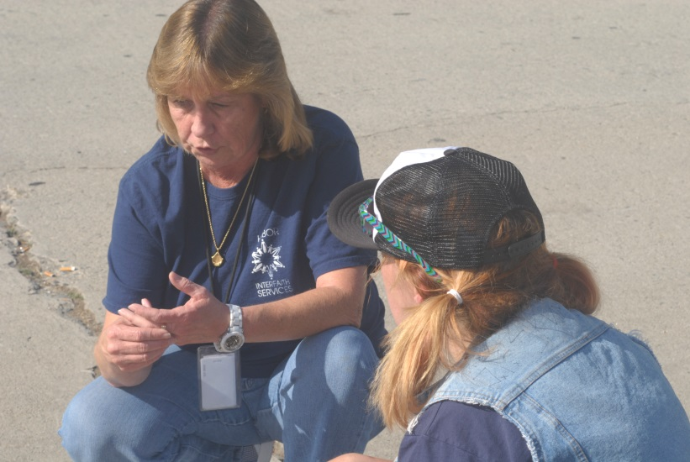
“We’ve done a lot of work to get them (the homeless) into permanent housing,” Ms. Weaver said. “We’ve placed 11 homeless people from the park into housing so far, but we feel that more can be done for the population that’s down there. So, we’re doing this.”
Shari Weaver (facing) working with a homeless woman outside the park. Photo by Alex Devin.
On May 3 through May 6, the agencies join forces to address individuals at an encampment of 20 to 30 people staking residence on the lawn in a beloved park across from the post office. The effort is managed by the Coordinated Entry System (CES), a partnership between dozens of housing and social service providers in the South Bay funded by the United Way Home for Good and the Los Angeles Homeless Services Authority’s Rapid Rehousing Program. Its goal is to place the homeless in permanent housing.
The problem in Los Angeles County is particularly dire. There are 44,000 homeless people here, a 12 percent increase since 2013. The reasons are complicated, but there are two that stand out: a low vacancy rate and a lack of affordable rental units. According to Zillow.com, Los Angeles County has a 4.3 percent vacancy rate compared to 8.2 percent nationwide. The National Apartment List Rent Report for May published the average rent for Los Angeles at $2,210 per month, the seventh highest in the country. A year’s rent, here, is equivalent to what a low-wage earner makes in a year.
The intervention group, coordinated by Harbor Interfaith, has the following objectives:
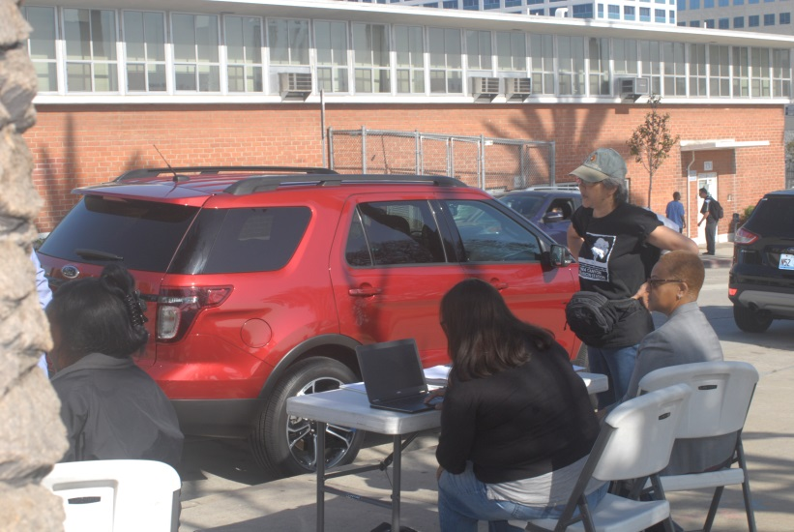
- connect the homeless to the Coordinated Entry System
- complete case assessments on everyone in the park as well develop a housing plan
- help the homeless obtain the needed documents to secure work and housing, such as driver’s license or a social
Stations are set up to connect the homeless to housing and services and to transport them to agencies to acquire documents. Photo by Alex Devin.
security card
- create a replicable intervention model for other encampments
Nicole Deering, Manager of City Services for City Council District 15, was at the encampment this morning. Mrs. Deering coordinates city resources for Los Angeles City Councilman Joe Buscaino.
“We’ve been working hard on the homeless issue,” Mrs. Deering said, “and we’re trying to find ways to remove the roadblocks to housing. In addition to our homeless outreach team, which is here today, we’re working on a storage facility in San Pedro where homeless people can store things for free, and on providing information for landlords and property owners on how to register for Section 8 funds. The Councilman also chairs the South Bay Council of Governments, which works on ways to serve the homeless not just in places like San Pedro and Wilmington, but also in the nearby suburban communities.”
"A comprehensive and regional approach to homelessness is essential to help us end this crisis," said Councilman Joe Buscaino. "My office is proud to partner with these dedicated organizations to get homeless individuals to accept services and into housing."
“We’re no longer working in silos as single agencies,” Ms. Weaver concluded. “Homelessness is a complicated problem that requires all of us to work together. The project in the park is a hopeful solution for a problem that seems to grow. We’re hoping that by bringing in all of these agencies to help, we’ll make significant connections to housing for most and further connect them to the needed services to keep them housed.”
---End of Release---

What is Harbor Interfaith Services?

Harbor Interfaith Services (HIS) empowers the homeless and working poor to achieve self-sufficiency by providing support services including shelter, transitional housing, food, job placement, advocacy, childcare, education, and life-skills training. HIS is a non-profit organization serving the South Bay communities of Los Angeles County including San Pedro, Harbor City, Harbor Gateway, Lomita, Torrance, Wilmington, and Long Beach.

